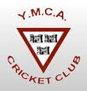

YMCA Cricket Club
Annual General Meeting 2013
Claremont Road
December 4, 2013

- President’s Introduction
- Apologies
- Minutes of 2012 AGM and matters arising
- Honorary Secretary’s Annual Report
- Report of Youth Cricket for 2013
- Honorary Treasurer’s Report (2013 Accounts and 2014 Budget)
- Motion (notice given) – “To adopt the YMCA Keeping Children Safe Plan”
- Election of Officers for 2014
- Any Other Business

